**Lab 1**

**Angular Installation**

**(Ahmed Ashraf Ibrahim)**

**1- install Node (npm)**

**2- install angular**

**>> npm i @angular/cli –g**

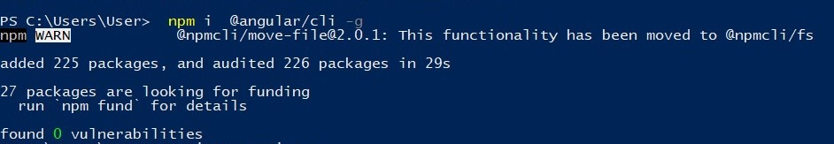

**3- install typescript**

**>> npm i typescript –g**

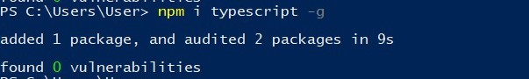

**4- make sure of installation**

**>> ng version**

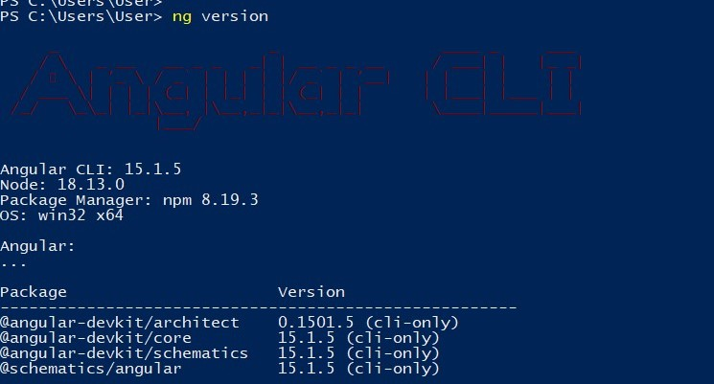

**5-Create Project**

**>> ng new lab1**

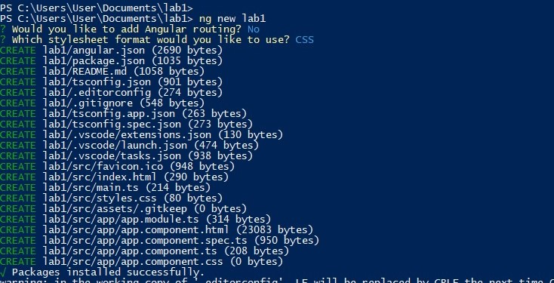

**6- run server**

**To auto run**

**>> ng serve -o**

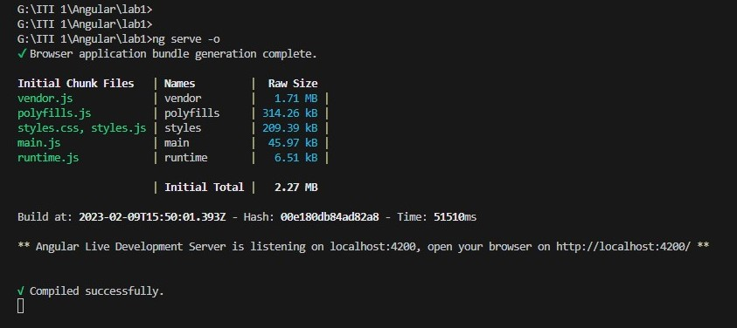

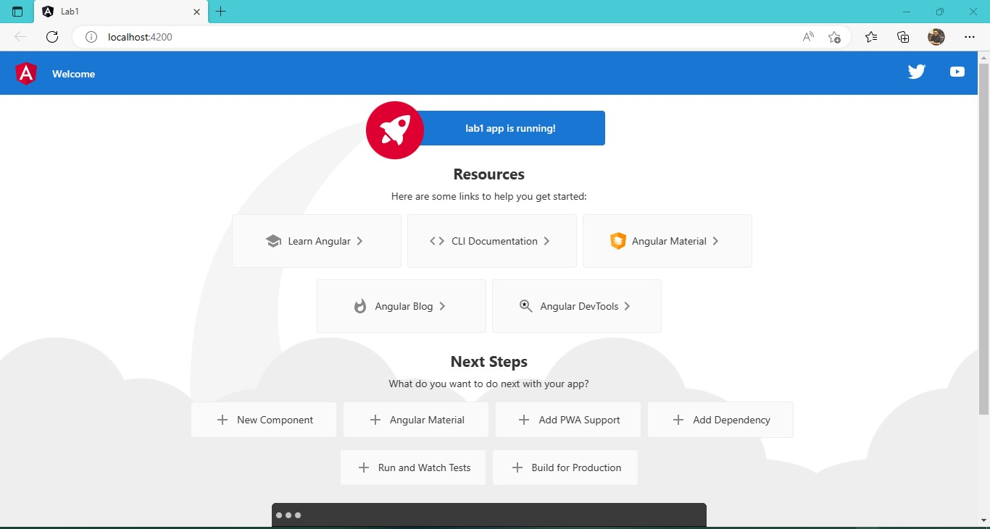

**Q2 : UML Diagram to typescript code :**

